College of Engineering and Technology
Web Engineering Department

PROJECT DOCUMENTATION
FreshMart Web
Project Title: FreshMart Web - Online Supermarket Website
Supervised By: [Dr. / Amr Fahmy]
Course: Web Engineering
Semester: [Semester 8 ]
Academic Year: 2025 / 2026

Website Url: https://freshmartproject.onrender.com/
Github Url: https://github.com/Amr-Khaled2004/FreshMartProject.git

Table of Contents
1. Project Team
2. Introduction & Problem Statement
3. Project Objectives
4. Technology Stack
5. System Architecture & Design
6. Project Steps & Phases
7. Group Task Distribution
8. Development Timeline
9. Full Project Documentation
10. Submission Checklist

1. Project Team

1.1 Team Members
Full Name | College ID | Role / Responsibility | Email
Nour Shafie | [221005721] | Frontend: home page, product catalog/cards, search/category/sort, Add to Cart stock validation; deployment and documentation | nourshafie22@gmail.com
Dania Yasser | [221004605] | Frontend: checkout form, payment validation, order placement UI, order history, responsive review | daniagamal0@gmail.com
Talia Hussein | [221006502] | Frontend: login/register, user session, token storage, dynamic navbar, cart page controls | taliaalnayef3@gmail.com
Amr Khaled | [221004748] | Backend: Express setup, MongoDB connection, User model, register/login APIs, JWT, route protection | amrksayed200@gmail.com
Ziad Tarek | [221006730] | Backend: product/order APIs, stock changes, admin management, cancellation stock restore, email/outbox logic | ziadghamry6@gmail.com

1.2 Sub-Group Distribution
Sub-Group | Member(s) | Module / Layer | Key Deliverable
Frontend | Nour Shafie, Talia Hussein, Dania Yasser | UI pages, user flow, cart, checkout, and responsiveness | Home page, product catalog/cards, search/category/sort, login/register, session/token handling, dynamic navbar, cart controls, checkout, order history, and responsive review
Backend / Database | Amr Khaled | Express setup, MongoDB connection, user model, authentication, route protection | Configured Express backend, connected MongoDB, created User model, implemented register/login APIs, JWT authentication, and protected routes
Backend / Admin & Orders | Ziad Tarek | Product/order APIs, stock logic, admin management, cancellation, outbox logic | Implemented product/order endpoints, stock updates, admin product/order management, cancellation stock restore, and email/outbox logic
DevOps / QA / Documentation | Nour Shafie + all members | Render deployment, testing, documentation, presentation, demo support | Hosted the project using Render, tested main flows, finalized the report/slides, and prepared the live demo

2. Introduction & Problem Statement

2.1 Background
FreshMart Web is an online supermarket web application designed to simulate a real e-commerce grocery experience. The application allows customers to browse grocery products, create accounts, log in securely, add items to cart, place orders, and track their orders. It also includes an admin side for product and order management. The project demonstrates core Web Engineering concepts including client-server architecture, REST APIs, authentication, authorization, data persistence, and deployment.

2.2 Problem Statement
- Customers need a simple online supermarket interface to view available products and order groceries remotely.
- Manual product and order handling can be slow and error-prone without a centralized management interface.
- A supermarket website requires secure login, role-based access, stock handling, and organized order processing.
- The project needs an integrated frontend and backend that can be deployed online for a live demo.

2.3 Motivation
The motivation behind FreshMart Web is to build a realistic web application that connects user experience with backend business logic. It helps the team practice how modern websites handle authentication, product data, cart/order flows, admin control, and production deployment.

3. Project Objectives
- Build a multi-page online supermarket website with customer and admin interfaces.
- Implement secure user registration and login using hashed passwords and JWT authentication.
- Create RESTful API endpoints for products, orders, authentication, and admin actions.
- Store and manage project data using MongoDB collections for users, products, and orders.
- Integrate frontend pages with backend APIs for products, cart, checkout, and order management.
- Deploy the project online using Render and prepare a final report and presentation for a five-member team.

4. Technology Stack
Layer | Technology / Tool | Purpose / Notes
Frontend Framework | HTML5, CSS3, JavaScript | Client-side pages, DOM manipulation, product display, cart interactions
Styling | CSS / responsive layout techniques | Visual design, grids, forms, navigation, and responsive behavior
Backend Framework | Node.js + Express.js | Server-side logic and REST API endpoints
Database | MongoDB / MongoDB Atlas | Persistent database storage for users, products, and orders
ORM / ODM | Mongoose | ODM for defining schemas/models and interacting with MongoDB collections
Authentication | JWT + bcryptjs | Token-based sessions and secure password hashing
Middleware | cors, express.json, custom protect/adminOnly | CORS handling, JSON parsing, protected routes, role-based access
Version Control | Git + GitHub | Source code management and deployment connection
Deployment | Render | Single live deployment for the Express backend and frontend using Render
Testing | Postman, browser testing, Chrome DevTools | API checks, manual UI testing, responsiveness checks

5. System Architecture & Design

5.1 High-Level Architecture
The application follows a client-server architecture. The browser loads the frontend pages and sends HTTP requests to the Express server. The server handles authentication, authorization, business logic, and data operations. The database layer is MongoDB, which stores users, products, and orders in structured collections for persistent project data.
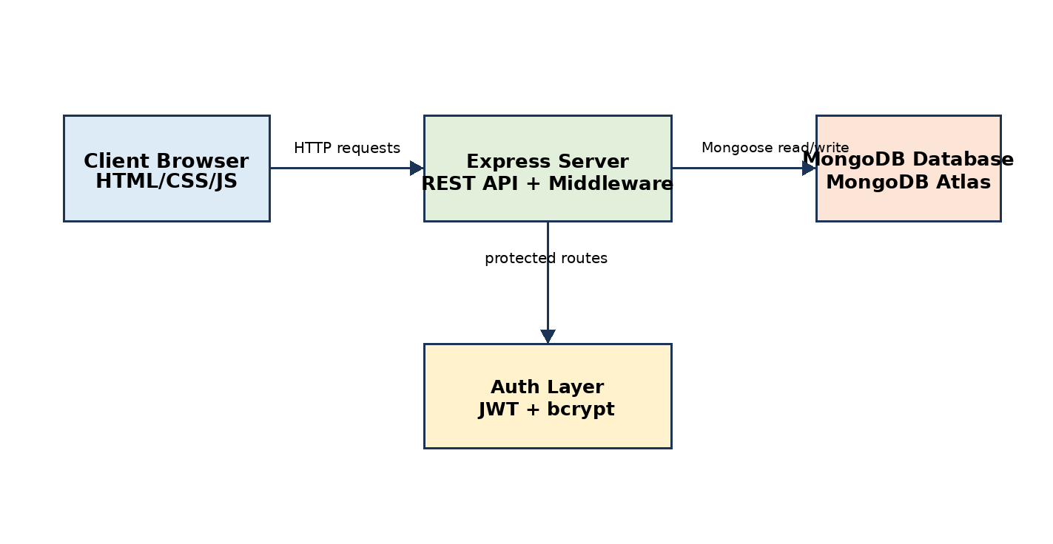

5.2 Frontend Architecture
- Pages: index/home, login/register, cart, checkout, admin dashboard, and supporting product pages.
- State approach: browser local storage/session data plus API responses for logged-in user actions.
- Routing approach: multi-page static website using HTML file navigation and JavaScript event handling.

5.3 Backend Architecture
- REST API implemented using Express.js and connected to MongoDB using Mongoose.
- Middleware includes CORS, JSON parsing, JWT protection, and admin-only access control.
- Main route groups: authentication, products, customer orders, and admin orders.
- Business logic includes product retrieval from MongoDB, product creation/deletion, placing orders, checking stock, and updating order status.

5.4 Database Schema
MongoDB is used as the main database instead of the previous database.json file. The backend connects to MongoDB using Mongoose and stores application data in separate collections.
Main collections:
Collection / Model | Main Fields | Purpose
Users | name, email, password, role, createdAt | Stores customer/admin accounts and authentication data
Products | name, category, price, image, stock, description | Stores supermarket product catalog and inventory information
Orders | userId, items, totalPrice, address, paymentMethod, status, createdAt | Stores customer orders and supports admin order tracking
Relationships: each order references the user who placed it, and each order item references a product. This keeps the system organized and allows the admin dashboard to read product and order data directly from MongoDB.
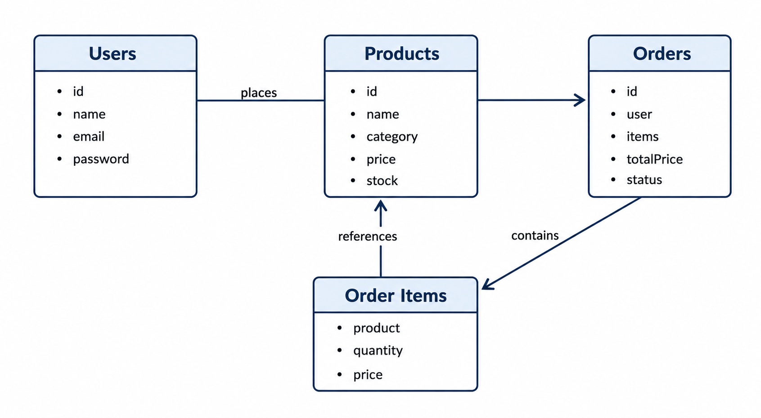

6. Project Steps & Phases
Phase | Step / Task | Expected Output / Deliverable
Phase 1 | Project planning, scope definition, page list, and feature selection | Approved project idea and required features
Phase 2 | Database structure design for users, products, and orders | MongoDB collections, Mongoose schemas, and sample seed data
Phase 3 | Environment setup, GitHub repository, folder structure, and MongoDB connection setup | Initialized frontend/backend folders and configured MongoDB connection
Phase 4 | Backend development: authentication, product API, order API, admin logic | Working Express endpoints
Phase 5 | Frontend development: pages, forms, product cards, cart, checkout, admin | Functional user interface connected to the API
Phase 6 | Security and role-based access | JWT login, bcrypt password hashing, admin-only routes
Phase 7 | Testing and bug fixing | Verified main user/admin flows
Phase 8 | Render deployment and final delivery | Live Render website, documentation report, and presentation slides

7. Group Task Distribution
Module / Feature | Assigned Member(s) | Sub-Group | Status
Home Page & Product Catalog | Nour Shafie | Frontend | Completed
Product Cards, Search, Category & Sort | Nour Shafie | Frontend | Completed
Login/Register, Session & Dynamic Navbar | Talia Hussein | Frontend | Completed
Cart Page Controls & Add-to-Cart Stock Validation | Nour Shafie + Talia Hussein | Frontend | Completed
Checkout, Payment Validation, Order Placement UI & Order History | Dania Yasser | Frontend | Completed
Express Setup, MongoDB Connection, User Model & Auth APIs | Amr Khaled | Backend / MongoDB | Completed
JWT, Route Protection & Protected Middleware | Amr Khaled | Backend / Security | Completed
Product/Order APIs, Stock Changes, Admin Management, Cancellation Restore & Email/Outbox Logic | Ziad Tarek | Backend / Admin | Completed
Render Deployment, Documentation, QA & Demo Support | Nour Shafie + all members | DevOps / QA | Completed

8. Development Timeline
Week | Phase / Task | Responsible Sub-Group | Deliverable
1 | Kickoff, requirements, pages, and feature planning | All | Project scope and feature list
2 | Database design and API contract | Backend + Database | Database schema and endpoint list
3 | Environment setup, GitHub workflow, folder structure | All | Working local development environment
4 | Backend API development: auth, products, orders | Backend | Core backend endpoints
5 | Frontend development: layout, product cards, cart, checkout | Frontend | Core pages and UI components
6 | Frontend-backend integration and role-based access | All | Connected application
7 | Testing, bug fixing, and responsiveness checks | QA + All | Tested website and fixed bugs
8 | Render deployment, final report, and presentation preparation | DevOps + All | Live Render demo app, report, and slides

9. Full Project Documentation

9.1 Features & Functional Requirements
- User registration and login with hashed password storage.
- JWT-based authentication for protected customer and admin endpoints.
- Product catalog display for customers.
- Cart and checkout flow for placing orders.
- Order creation with item quantities, total price, address, payment method, and status.
- Admin-only product management: add and delete products.
- Admin-only order management: view all orders and update order status.
- Role-based authorization to separate customer and admin features.

9.2 Non-Functional Requirements
- Performance: lightweight static frontend and MongoDB-backed API suitable for project demo use and persistent data storage.
- Security: passwords hashed with bcryptjs; protected APIs require JWT; admin routes require admin role.
- Usability: clear page navigation, product cards, forms, and admin actions.
- Responsiveness: pages should be tested on desktop and mobile widths using browser developer tools.
- Maintainability: separate frontend and backend folders; readable API structure; reusable middleware; organized Mongoose models for users, products, and orders.

9.3 API Documentation
Endpoint | Method | Description | Auth Required | Response
/api/auth/register | POST | Register a new customer account | No | 201 Created + user data
/api/auth/login | POST | Login and receive JWT token | No | 200 OK + token + user
/api/products | GET | Get all products | No | 200 OK + products list
/api/products | POST | Add a new product | Admin | 201 Created + product
/api/products/:id | DELETE | Delete a product | Admin | 200 OK message
/api/orders | POST | Place a new customer order | Yes | 201 Created + order
/api/orders/my-orders | GET | Get orders for the logged-in customer | Yes | 200 OK + orders
/api/orders | GET | Get all orders for admin dashboard | Admin | 200 OK + orders
/api/orders/:id/status | PUT | Update order status | Admin | 200 OK + updated order

9.4 UI/UX Design Notes
- Design language: fresh supermarket/e-commerce theme with product cards, navigation, cart, and checkout pages.
- Color direction: green accents to reflect grocery/fresh products, supported by clean white backgrounds and readable dark text.
- Typography: standard web-safe fonts with clear headings, labels, and buttons.
- Key user flow: Home/Product browsing -> Login/Register -> Add to Cart -> Checkout -> Order history.
- Admin flow: Admin login -> Dashboard -> Manage products -> View/update orders.

9.5 Testing Plan
Test Type | Tool / Method | Scope | Pass Criteria
API Testing | Postman / browser requests | Auth, products, orders, admin endpoints | Correct 2xx/4xx responses and JSON output
UI Testing | Manual browser testing | Navigation, forms, cart, checkout, admin pages | No broken pages or incorrect flows
Authentication Testing | Manual login/register tests | JWT token, protected routes, admin-only access | Users cannot access admin actions without admin role
Responsiveness | Chrome DevTools device toolbar | Mobile and desktop widths | No major layout breaks
Deployment Testing | Render live URL testing | Frontend/backend connection and MongoDB persistence | Products and API data load correctly from the Render deployment
Database Testing | MongoDB Atlas / Compass and API tests | Users, products, and orders collections | Data is saved, updated, retrieved, and deleted correctly through the API

9.6 Deployment & DevOps
- Version control is managed using Git and GitHub.
- The project was deployed using Render so the website can be accessed online from one hosted service for the live demo.
- For Render deployment, server.js uses process.env.PORT and express.static to serve the frontend folder from the Express application.
- Environment-sensitive values such as JWT secrets and the MongoDB connection string (MONGO_URI) should be moved to environment variables for production-level security.
- Final demo should confirm that product loading, login, cart, checkout, admin functions, and MongoDB data persistence work from the hosted URL.

10. Submission Checklist
☑ System architecture diagram completed
☑ Database ERD finalized
☑ All API endpoints documented
☑ Frontend pages implemented and responsive
☑ Backend API tested and returning correct responses
☑ Authentication and authorization working correctly
☑ Frontend and backend integrated
☑ Database seeded with sample data
☑ Testing plan prepared
☑ Application deployed on Render
☑ Environment variables reviewed
☑ Code pushed to GitHub
☑ Final project report completed and formatted
☑ Presentation slides prepared
☑ Live demo rehearsed by all team members

